CCNPv7 SWITCH

Chapter 5-2 Lab – DHCP INSTRUCTOR VERSION

1. Topology

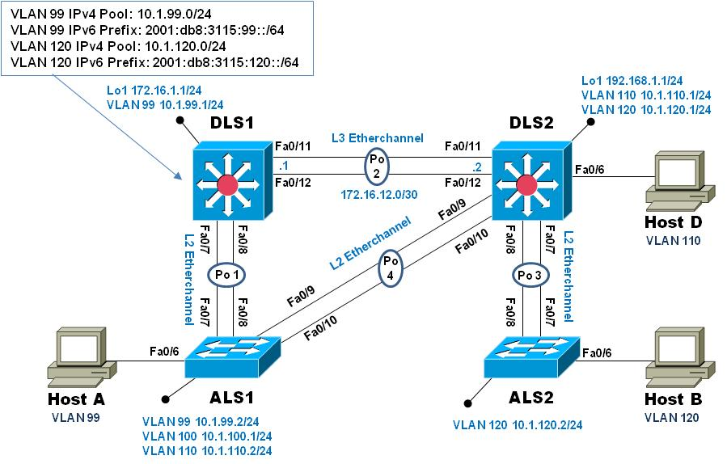

1. Objectives

* Configure DHCP for IPv4
* Configure Stateless DHCP for IPv6
* Configure Stateful DHCP for IPv6

1. Background

To practice the various configuration and options associated with DHCP for IPv4 and IPv6, you will configure a DHCP server on switch DLS1. Hosts A and B will receive IP addresses from DLS1 and validate continued connectivity.

**Note**: This lab uses Cisco Catalyst 3560 and 2960 switches running Cisco IOS 15.0(2)SE6 IP Services and LAN Base images, respectively. The 3560 and 2960 switches are configured with the SDM templates “dual-ipv4-and-ipv6 routing” and “lanbase-routing”, respectively. Depending on the switch model and Cisco IOS Software version, the commands available and output produced might vary from what is shown in this lab. Catalyst 3650 switches (running any Cisco IOS XE release) and Catalyst 2960-Plus switches (running any comparable Cisco IOS image) can be used in place of the Catalyst 3560 switches and the Catalyst 2960 switches.

* 1. Verify SDM template (dual-ipv4-and-ipv6 routing / lanbase-routing)

This lab starts with the switches being configured from the previous lab (5-1, InterVLAN Routing). To support IPv6, the correct SDM template must be in use on your switches (the 3560 will use **dual-ipv4-and-ipv6 routing** while the 2960 will use **lanbase-routing**). Verify this is the case on all four switches. If you must change the SDM template, do so (use the configuration command **sdm prefer dual-ipv4-and-ipv6 routing** on the 3560s and **sdm prefer lanbase-routing** on the 2960s) and then save the switch configuration and reload the switch to have the new SDM template take effect.

* 1. Configure IPv4 DHCP server on DLS1 for VLAN 99 and 120

Configure a DHCP server for IPv4 on DLS1 using the following parameters:

* For VLAN 99:
  1. Exclude addresses 10.1.99.1 through 10.1.99.2 and 10.1.99.100 through 10.1.99.104
  2. Set the default router to 10.1.99.1
  3. Set the DNS server to 10.1.99.100
* For VLAN 120:
  1. Exclude addresses 10.1.120.1 through 10.1.120.2 and 10.1.120.100 through 10.1.120.104
  2. Set the default router to 10.1.120.1
  3. Set the DNS server to 10.1.99.100

Example of VLAN 99 pool configuration:

DLS1#**conf t**

Enter configuration commands, one per line. End with CNTL/Z.

DLS1(config)#**ip dhcp excluded-address 10.1.99.1 10.1.99.2**

DLS1(config)#**ip dhcp excluded-address 10.1.99.100 10.1.99.104**

DLS1(config)#**ip dhcp pool VLAN99_DHCP**

DLS1(dhcp-config)#**network 10.1.99.0 255.255.255.0**

DLS1(dhcp-config)#**default-router 10.1.99.1**

DLS1(dhcp-config)#**dns-server 10.1.99.100**

DLS1(dhcp-config)#**exit**

DLS1(config)#**end**

DLS1#

* 1. Configure IPv6 support on all switches

Configure IPv6 support addresses on all switches using the following addresses:

* Enable IPv6 unicast-routing on DLS1 and DLS2
* Configure IPv6 addressing as shown in the table:

|  |  |  |  |
| --- | --- | --- | --- |
| Device | Interface | Link-Local Address | Global Unicast Address |
| DLS1 | VLAN99 | Fe80::d1 | 2001:db8:3115:99::d1/64 |
| DLS2 | VLAN110 | Fe80::d2 | 2001:db8:3115:110::d2/64 |
| DLS2 | VLAN120 | Fe80::d2 | 2001:db8:3115:120::d2/64 |
| ALS1 | VLAN99 | Fe80::a1 | 2001:db8:3115:99::a1/64 |
| ALS2 | VLAN120 | Fe80::a2 | 2001:db8:3115:120::a2/64 |
| DLS1 | Po2 | Fe80::d1 | 2001:db8:3115:12::d1/64 |
| DLS2 | Po2 | Fe80::d2 | 2001:db8:3115:12::d2/64 |

* 1. Configure IPv6 Routing at DLS1 and DLS2

At DLS1 and DLS2, create an IPv6 default route that points to the other switch. Example from DLS1:

DLS1(config)#**ipv6 route ::/0 2001:db8:3115:12::d2**

* 1. Configure a STATELESS DHCP server for IPv6 on DLS1 using the following parameters:
* Build a pool named MANAGEMENT_IPV6_DHCP
* Set the DNS server to 2001:db8:3115:99::100
* Associate the IPv6 pool with interface vlan 99 on DLS1
* Set the Other configuration flag on interface vlan 99 on DLS1

DLS1#**conf t**

Enter configuration commands, one per line. End with CNTL/Z.

DLS1(config)#**ipv6 dhcp pool MANAGEMENT_IPV6_DHCP**

DLS1(config-dhcpv6)#**dns-server 2001:db8:3115:99::100**

DLS1(config-dhcpv6)#**exit**

DLS1(config)#**interface vlan 99**

DLS1(config-if)#**ipv6 dhcp server MANAGEMENT_IPV6_DHCP**

DLS1(config-if)#**ipv6 nd other-config-flag**

DLS1(config-if)#**exit**

DLS1(config)#**end**

DLS1#

* 1. Configure DHCP Relay on DLS2 for the VLAN 120 network

Redirect IPv4 and IPv6 DHCP requests to DLS1 at 10.1.99.1 and 2001:db8:3115:99::d2 respectively

* 1. Configure switches for remote access

On each switch, create an enable secret password and configure the vty lines to allow remote access from other network devices.

DLS1 example:

DLS1(config)# **enable secret class**

DLS1(config)# **line vty 0 4**

DLS1(config-line)# **password cisco**

DLS1(config-line)# **login**

**Note**: The passwords configured here are required for NETLAB compatibility only and are NOT recommended for use in a live environment

* 1. Configure hosts for both IPv4 and IPv6 addresses

Hosts should be attached to interface F0/6 on DLS2, ALS1 and ALS2. On ALS1, change interface F0/6 from an access port in VLAN 100 to an access port in VLAN 99.

Interface F0/6 on DLS2 and ALS2 should still be configured from the previous lab, so no changes are needed (DLS2 F0/6 = VLAN 110, ALS2 F0/6 = VLAN 120).

For the rest of this step, you will work with PC A connected to ALS1.

Once the interface on ALS1 is associated with proper VLAN, use the commands appropriate to the PC operating system to obtain IPv4 and IPv6 addressing.

For a computer with Windows 7 installed (must be machine administrator): At the command prompt, issue the command **ipconfig /renew** to get an IPv4 address and **ipconfig /renew6** to get an IPv6 address.

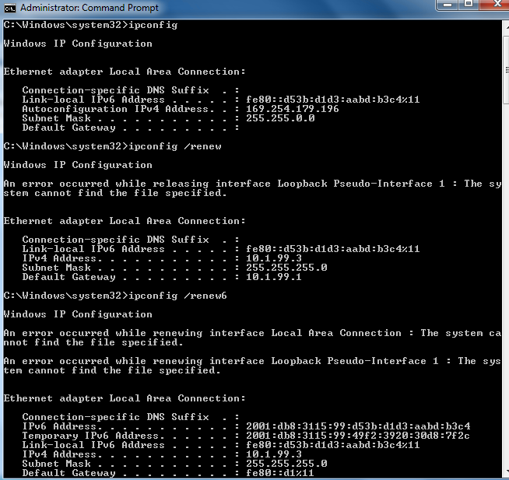

In the **ipconfig** output above, notice that there are two IPv6 addresses. The first address listed, 2001:db8:3115:99:d63b:d1d3:aabd:b3c4 is a *permanent* address while the second address listed, 2001:db8:3115:99:49f2:3920:30d8:72fc, is a *temporary* address.

Also notice that the interface portion of the permanent address is the same as the interface portion of the link-local address. The temporary address is generated automatically because privacy extensions are enabled.

The permanent address will be used in DNS registration and when this host is providing a service, while the temporary address will be used when this host is serving in the client role and requesting services from another host, with the idea that this helps provide some privacy to the host.

The temporary address is valid for one day then a new temporary address is generated and then the old temporary address goes into a "deprecated" mode for seven days. The "active" temporary address may also be referred to as "preferred".

The second thing to note is from the output of the **route print -6** command:

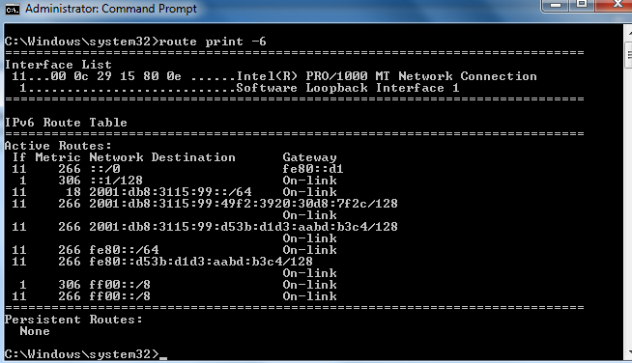

The default route, expressed as ::/0, points to the link-local address of the default gateway; there is also a route to the local IPv6 network 2001:db8:3115:99::/64 noted as "on link".

* 1. Test connectivity using IPv4 and IPv6 addresses

From Host A, attempt to ping and telnet to DLS2 using both IPv4 and IPv6 addresses. All attempts should succeed.

* 1. Configure Stateful DHCP for IPv6

In this step, you will configure Stateful DHCP for VLAN 120. In this scenario, DLS1 will be providing DHCP services for VLAN 120 even though it does not have an interface on VLAN 120. The DHCP Helper configuration from step 6 will allow DHCP traffic from HOST B to reach the DHCP server. However, some additional configuration is necessary on DLS2 to ensure everything works as expected.

In most cases when an external DHCP server is used, the device sourcing router advertisement (DLS2 in this instance) simply has to have the "M" flag enabled on the interface receiving the DHCP Solicit messages.

The M flag being received in the RA will cause the host to ask for a DHCP address. However, it will also configure a SLAAC address using the prefix information in the RA. This is due to the fact that the autoconfig flag is on by default. The “A” flag tells the host to use the RA to build an address for the interface. We will illustrate this with a very different DHCP prefix and a couple of packet captures and debug outputs in a few moments.

* Configure DLS1 with an IPv6 DHCP pool named VLAN120-IPV6-POOL
* Set the address prefix to 3333:120::/64
* Set the DNS server to 2001:db8:3115:99::100
* Set the domain name to switch.ccnp
* Apply this DHCP configuration to interface Port-Channel 2

DLS1(config)# **ipv6 dhcp pool VLAN120-IPV6-POOL**

DLS1(config-dhcpv6)# **address prefix 3333:120::/64**

DLS1(config-dhcpv6)# **dns-server 2001:db8:3115:99::100**

DLS1(config-dhcpv6)# **domain-name switch.ccnp**

DLS1(config-dhcpv6)# **exit**

DLS1(config)# **interface port-channel 2**

DLS1(config-if)# **ipv6 dhcp server VLAN120-IPV6-POOL**

* Set the managed configuration flag on interface vlan 120 on DLS2

DLS2(config)# **int vlan 120**

DLS2(config-if)# **ipv6 nd managed-config-flag**

DLS2(config-if)# **exit**

* 1. Configure the hosts for IPv6 addresses

Use the previously provided instructions on Host B to obtain an IPv6 address.

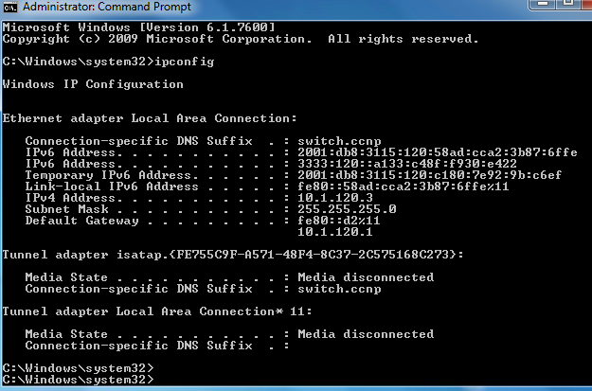

Notice the IPv6 addresses. This machine has two addresses with the 2001:db8:3115:120::/64 prefix, and only one from the 3333:120::/64 prefix. What happened?

The results here are a result of the autoconfig flag being set in the router advertisements sent by DLS2. The “A” flag being on tells the host to use the RA to create an address, *even if* the “M” flag is on. To see the “A” flag, you could use wireshark on the host or simply **debug ipv6 nd** on DLS2:

DLS2#

*Mar 1 06:14:54.664: ICMPv6-ND: Request to send RA for FE80::D2

*Mar 1 06:14:54.664: ICMPv6-ND: Setup RA from FE80::D2 to FF02::1 on Vlan120

*Mar 1 06:14:54.664: ICMPv6-ND: Setup RA common:Managed address configuration

*Mar 1 06:14:54.664: ICMPv6-ND: MTU = 1500

*Mar 1 06:14:54.664: ICMPv6-ND: prefix = 2001:DB8:3115:120::/64 onlink autoconfig

*Mar 1 06:14:54.664: ICMPv6-ND: 2592000/604800 (valid/preferred)

We used different numbers on the DLS2 VLAN120 interface and the DHCP scope to illustrate the impact of the autoconfig flag.

To make DLS2 remove the autoconfig flag from the RA, add the **ipv6 nd prefix xx::/yy no-autoconfig** interface configuration command (this would be the prefix assigned to int VLAN 120):

DLS2(config)#**int vlan 120**

DLS2(config-if)#**ipv6 nd prefix 2001:db8:3115:120::/64 no-autoconfig**

DLS2(config-if)#**end**

*Mar 1 06:19:21.891: ICMPv6-ND: Setup RA common:Managed address configuration

*Mar 1 06:19:21.891: ICMPv6-ND: MTU = 1500

*Mar 1 06:19:21.891: ICMPv6-ND: prefix = 2001:DB8:3115:120::/64 onlink

*Mar 1 06:19:21.891: ICMPv6-ND: 2592000/604800 (valid/preferred)

To completely discard temporary addresses from an interface, you need to disable it and then re-enable it. This should automatically release and renew all the IP addresses (v4 and v6) on the interface:

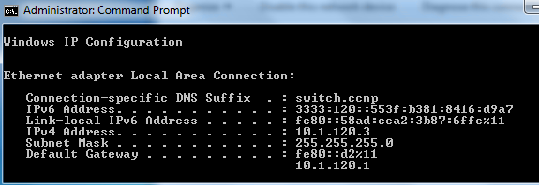

As you can see, not only did the 2001:db8:3115:120::/64 permanent address disappear, but so did the temporary address -- because the temporary address is only formed based on an RA with the autoconfig flag on.

Now, reconfigure the DHCP pool at DLS1 to use the correct prefix for VLAN 120 (2001:db8:3115:120::/64), disable and re-enable the adapter on HOST B, and the host should receive a single IPv6 address

DLS1(config)# **no ipv6 dhcp pool VLAN120-IPV6-POOL**

DLS1(config)# **ipv6 dhcp pool VLAN120-IPV6-POOL**

DLS1(config-dhcpv6)# **address prefix 2001:db8:3115:120::/64**

DLS1(config-dhcpv6)# **dns-server 2001:db8:3115:99::100**

DLS1(config-dhcpv6)# **domain-name switch.ccnp**

DLS1(config-dhcpv6)# **interface po2**

DLS1(config-if)# **ipv6 dhcp server VLAN120-IPV6-POOL**

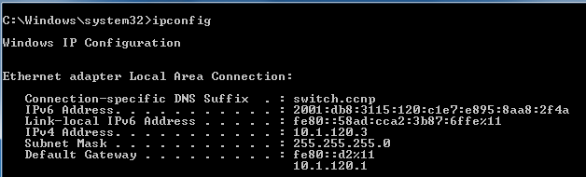

* 1. Test connectivity

As you did in step 9, test connectivity between the hosts using PING and TELNET.

* 1. End of Lab

Use the tcl script “reset.tcl” created in Lab 1 to clear and reload all of your switches before the next lab.

Device Configurations – INSTRUCTOR VERSION

DLS1

version 15.0

no service pad

service timestamps debug datetime msec

service timestamps log datetime msec

no service password-encryption

!

hostname DLS1

!

boot-start-marker

boot-end-marker

!

enable secret 5 $1$UODX$lGzxXLeee.fhKqlaTp/j8.

!

no aaa new-model

system mtu routing 1500

vtp mode transparent

ip routing

no ip domain-lookup

ip domain-name CCNP.NET

!

ip dhcp excluded-address 10.1.99.1 10.1.99.2

ip dhcp excluded-address 10.1.99.100 10.1.99.104

ip dhcp excluded-address 10.1.120.1 10.1.120.2

ip dhcp excluded-address 10.1.120.100 10.1.120.104

!

ip dhcp pool VLAN99_DHCP

network 10.1.99.0 255.255.255.0

default-router 10.1.99.1

dns-server 10.1.99.100

!

ip dhcp pool VLAN120_DHCP

network 10.1.120.0 255.255.255.0

default-router 10.1.120.1

dns-server 10.1.120.100

!

!

ipv6 unicast-routing

ipv6 dhcp pool MANAGEMENT_IPV6_DHCP

dns-server 2001:DB8:3115:99::100

!

ipv6 dhcp pool VLAN120-IPV6-POOL

address prefix 3333:120::/64

dns-server 2001:DB8:3115:99::100

domain-name switch.ccnp

!

spanning-tree mode pvst

spanning-tree extend system-id

!

vlan internal allocation policy ascending

!

vlan 99

name Management

!

interface Loopback1

ip address 172.16.1.1 255.255.255.0

!

interface Port-channel1

switchport trunk encapsulation dot1q

switchport trunk allowed vlan 1-109,111-4094

switchport mode trunk

!

interface Port-channel2

no switchport

ip address 172.16.12.1 255.255.255.252

ipv6 address FE80::D1 link-local

ipv6 address 2001:DB8:3115:12::D1/64

ipv6 dhcp server VLAN120-IPV6-POOL

!

interface FastEthernet0/1

shutdown

!

interface FastEthernet0/2

shutdown

!

interface FastEthernet0/3

shutdown

!

interface FastEthernet0/4

shutdown

!

interface FastEthernet0/5

shutdown

!

interface FastEthernet0/6

shutdown

!

interface FastEthernet0/7

switchport trunk encapsulation dot1q

switchport trunk allowed vlan 1-109,111-4094

switchport mode trunk

channel-group 1 mode desirable

!

interface FastEthernet0/8

switchport trunk encapsulation dot1q

switchport trunk allowed vlan 1-109,111-4094

switchport mode trunk

channel-group 1 mode desirable

!

interface FastEthernet0/9

shutdown

!

interface FastEthernet0/10

shutdown

!

interface FastEthernet0/11

no switchport

no ip address

channel-group 2 mode desirable

!

interface FastEthernet0/12

no switchport

no ip address

channel-group 2 mode desirable

!

interface FastEthernet0/13

shutdown

!

interface FastEthernet0/14

shutdown

!

interface FastEthernet0/15

shutdown

!

interface FastEthernet0/16

shutdown

!

interface FastEthernet0/17

shutdown

!

interface FastEthernet0/18

shutdown

!

interface FastEthernet0/19

shutdown

!

interface FastEthernet0/20

shutdown

!

interface FastEthernet0/21

shutdown

!

interface FastEthernet0/22

shutdown

!

interface FastEthernet0/23

shutdown

!

interface FastEthernet0/24

shutdown

!

interface GigabitEthernet0/1

shutdown

!

interface GigabitEthernet0/2

shutdown

!

interface Vlan1

no ip address

shutdown

!

interface Vlan99

ip address 10.1.99.1 255.255.255.0

ipv6 address FE80::D1 link-local

ipv6 address 2001:DB8:3115:99::D1/64

ipv6 nd other-config-flag

ipv6 dhcp server MANAGEMENT_IPV6_DHCP

!

ip http server

ip http secure-server

!

ip route 0.0.0.0 0.0.0.0 Port-channel2 172.16.12.2

ip route 10.1.100.0 255.255.255.0 Vlan99

!

ipv6 route ::/0 2001:DB8:3115:12::D2

!

line con 0

exec-timeout 0 0

logging synchronous

line vty 0 4

password cisco

login

line vty 5 15

password cisco

login

!

end

DLS2

version 15.0

no service pad

service timestamps debug datetime msec

service timestamps log datetime msec

no service password-encryption

!

hostname DLS2

!

boot-start-marker

boot-end-marker

!

enable secret 5 $1$dGUV$SFg4hhoNpkirRn1mrh5.v/

!

no aaa new-model

system mtu routing 1500

vtp mode transparent

ip routing

no ip domain-lookup

ip domain-name CCNP.NET

!

ipv6 unicast-routing

ipv6 dhcp pool VLAN120-IPV6-POOL

address prefix 2001:DB8:3115:120::/64

dns-server 2001:DB8:3115:99::100

domain-name switch.ccnp

!

spanning-tree mode pvst

spanning-tree extend system-id

!

vlan internal allocation policy ascending

!

vlan 110

name Management

!

vlan 120

name Local

!

interface Loopback1

ip address 192.168.1.1 255.255.255.0

!

interface Port-channel2

no switchport

ip address 172.16.12.2 255.255.255.252

ipv6 address FE80::D2 link-local

ipv6 address 2001:DB8:3115:12::D2/64

ipv6 dhcp server VLAN120-IPV6-POOL

!

interface Port-channel3

switchport trunk encapsulation dot1q

switchport mode trunk

!

interface Port-channel4

switchport trunk encapsulation dot1q

switchport trunk allowed vlan 110

switchport mode trunk

!

interface FastEthernet0/1

shutdown

!

interface FastEthernet0/2

shutdown

!

interface FastEthernet0/3

shutdown

!

interface FastEthernet0/4

shutdown

!

interface FastEthernet0/5

shutdown

!

interface FastEthernet0/6

switchport access vlan 110

switchport mode access

spanning-tree portfast

!

interface FastEthernet0/7

switchport trunk encapsulation dot1q

switchport mode trunk

channel-group 3 mode desirable

!

interface FastEthernet0/8

switchport trunk encapsulation dot1q

switchport mode trunk

channel-group 3 mode desirable

!

interface FastEthernet0/9

switchport trunk encapsulation dot1q

switchport trunk allowed vlan 110

switchport mode trunk

channel-group 4 mode desirable

!

interface FastEthernet0/10

switchport trunk encapsulation dot1q

switchport trunk allowed vlan 110

switchport mode trunk

channel-group 4 mode desirable

!

interface FastEthernet0/11

no switchport

no ip address

channel-group 2 mode desirable

!

interface FastEthernet0/12

no switchport

no ip address

channel-group 2 mode desirable

!

interface FastEthernet0/13

shutdown

!

interface FastEthernet0/14

shutdown

!

interface FastEthernet0/15

shutdown

!

interface FastEthernet0/16

shutdown

!

interface FastEthernet0/17

shutdown

!

interface FastEthernet0/18

shutdown

!

interface FastEthernet0/19

shutdown

!

interface FastEthernet0/20

shutdown

!

interface FastEthernet0/21

shutdown

!

interface FastEthernet0/22

shutdown

!

interface FastEthernet0/23

shutdown

!

interface FastEthernet0/24

shutdown

!

interface GigabitEthernet0/1

shutdown

!

interface GigabitEthernet0/2

shutdown

!

interface Vlan1

no ip address

shutdown

!

interface Vlan110

ip address 10.1.110.1 255.255.255.0

ipv6 address FE80::D2 link-local

ipv6 address 2001:DB8:3115:110::D2/64

!

interface Vlan120

ip address 10.1.120.1 255.255.255.0

ip helper-address 10.1.99.1

ipv6 address FE80::D2 link-local

ipv6 address 2001:DB8:3115:120::D2/64

ipv6 nd prefix 2001:DB8:3115:120::/64 2592000 604800 no-autoconfig

ipv6 nd managed-config-flag

ipv6 dhcp relay destination 2001:DB8:3115:99::D1 Port-channel2

!

ip http server

ip http secure-server

!

ip route 0.0.0.0 0.0.0.0 Port-channel2 172.16.12.1

ip route 10.1.100.0 255.255.255.0 Vlan110

!

ipv6 route ::/0 2001:DB8:3115:12::D1

!

line con 0

exec-timeout 0 0

logging synchronous

line vty 0 4

password cisco

login

line vty 5 15

password cisco

login

!

end

ALS1

version 15.0

no service pad

service timestamps debug datetime msec

service timestamps log datetime msec

no service password-encryption

!

hostname ALS1

!

boot-start-marker

boot-end-marker

!

enable secret 5 $1$Aww4$5VLMKY7ovE8Xa4yNNEt8o.

!

no aaa new-model

system mtu routing 1500

vtp mode transparent

ip routing

!

!

no ip domain-lookup

ip domain-name CCNP.NET

!

spanning-tree mode pvst

spanning-tree extend system-id

!

vlan internal allocation policy ascending

!

vlan 99

name Management

!

vlan 100

name Local

!

vlan 110

name InterNode

!

interface Port-channel1

switchport trunk allowed vlan 1-109,111-4094

switchport mode trunk

!

interface Port-channel4

switchport trunk allowed vlan 110

switchport mode trunk

!

interface FastEthernet0/1

shutdown

!

interface FastEthernet0/2

shutdown

!

interface FastEthernet0/3

shutdown

!

interface FastEthernet0/4

shutdown

!

interface FastEthernet0/5

shutdown

!

interface FastEthernet0/6

switchport access vlan 100

switchport mode access

spanning-tree portfast

!

interface FastEthernet0/7

switchport trunk allowed vlan 1-109,111-4094

switchport mode trunk

channel-group 1 mode desirable

!

interface FastEthernet0/8

switchport trunk allowed vlan 1-109,111-4094

switchport mode trunk

channel-group 1 mode desirable

!

interface FastEthernet0/9

switchport trunk allowed vlan 110

switchport mode trunk

channel-group 4 mode desirable

!

interface FastEthernet0/10

switchport trunk allowed vlan 110

switchport mode trunk

channel-group 4 mode desirable

!

interface FastEthernet0/11

shutdown

!

interface FastEthernet0/12

shutdown

!

interface FastEthernet0/13

shutdown

!

interface FastEthernet0/14

shutdown

!

interface FastEthernet0/15

shutdown

!

interface FastEthernet0/16

shutdown

!

interface FastEthernet0/17

shutdown

!

interface FastEthernet0/18

shutdown

!

interface FastEthernet0/19

shutdown

!

interface FastEthernet0/20

shutdown

!

interface FastEthernet0/21

shutdown

!

interface FastEthernet0/22

shutdown

!

interface FastEthernet0/23

shutdown

!

interface FastEthernet0/24

shutdown

!

interface GigabitEthernet0/1

shutdown

!

interface GigabitEthernet0/2

shutdown

!

interface Vlan1

no ip address

shutdown

!

interface Vlan99

ip address 10.1.99.2 255.255.255.0

ipv6 address FE80::A1 link-local

ipv6 address 2001:DB8:3115:99::A1/64

!

interface Vlan100

ip address 10.1.100.1 255.255.255.0

!

interface Vlan110

ip address 10.1.110.2 255.255.255.0

!

ip default-gateway 10.1.99.1

ip http server

ip http secure-server

ip route 0.0.0.0 0.0.0.0 10.1.99.1

ip route 192.168.1.0 255.255.255.0 Vlan110

!

line con 0

exec-timeout 0 0

logging synchronous

line vty 0 4

password cisco

login

line vty 5 15

password cisco

login

!

end

ALS2

version 15.0

no service pad

service timestamps debug datetime msec

service timestamps log datetime msec

no service password-encryption

!

hostname ALS2

!

boot-start-marker

boot-end-marker

!

enable secret 5 $1$IGCP$.jEisXIWO7Ky/QAz7qK631

!

no aaa new-model

system mtu routing 1500

vtp mode transparent

!

no ip domain-lookup

ip domain-name CCNP.NET

!

spanning-tree mode pvst

spanning-tree extend system-id

!

vlan internal allocation policy ascending

!

vlan 120

name Management

!

interface Port-channel3

switchport mode trunk

!

interface FastEthernet0/1

shutdown

!

interface FastEthernet0/2

shutdown

!

interface FastEthernet0/3

shutdown

!

interface FastEthernet0/4

shutdown

!

interface FastEthernet0/5

shutdown

!

interface FastEthernet0/6

shutdown

!

interface FastEthernet0/7

switchport mode trunk

channel-group 3 mode desirable

!

interface FastEthernet0/8

switchport mode trunk

channel-group 3 mode desirable

!

interface FastEthernet0/9

shutdown

!

interface FastEthernet0/10

shutdown

!

interface FastEthernet0/11

shutdown

!

interface FastEthernet0/12

shutdown

!

interface FastEthernet0/13

shutdown

!

interface FastEthernet0/14

shutdown

!

interface FastEthernet0/15

shutdown

!

interface FastEthernet0/16

shutdown

!

interface FastEthernet0/17

shutdown

!

interface FastEthernet0/18

shutdown

!

interface FastEthernet0/19

shutdown

!

interface FastEthernet0/20

shutdown

!

interface FastEthernet0/21

shutdown

!

interface FastEthernet0/22

shutdown

!

interface FastEthernet0/23

shutdown

!

interface FastEthernet0/24

shutdown

!

interface GigabitEthernet0/1

shutdown

!

interface GigabitEthernet0/2

shutdown

!

interface Vlan1

no ip address

shutdown

!

interface Vlan120

ip address 10.1.120.2 255.255.255.0

ipv6 address FE80::A2 link-local

ipv6 address 2001:DB8:3115:120::A2/64

!

ip default-gateway 10.1.120.1

ip http server

ip http secure-server

!

line con 0

exec-timeout 0 0

logging synchronous

line vty 0 4

password cisco

login

line vty 5 15

password cisco

login

!

end

Device Configuration Scripts – INSTRUCTOR VERSION

DLS1

Lab 5-2

Step 2

en

conf t

ip dhcp excluded-address 10.1.99.1 10.1.99.2

ip dhcp excluded-address 10.1.99.100 10.1.99.104

ip dhcp pool VLAN99_DHCP

network 10.1.99.0 255.255.255.0

default-router 10.1.99.1

dns-server 10.1.99.100

exit

ip dhcp excluded-address 10.1.120.1 10.1.120.2

ip dhcp excluded-address 10.1.120.100 10.1.120.104

ip dhcp pool VLAN120_DHCP

network 10.1.120.0 255.255.255.0

default-router 10.1.120.1

dns-server 10.1.120.100

exit

Step 3

ipv6 unicast-routing

interface vlan 99

ipv6 address fe80::d1 link-local

ipv6 address 2001:db8:3115:99::d1/64

exit

interface port-channel 2

ipv6 address fe80::d1 link-local

ipv6 address 2001:db8:3115:12::d1/64

exit

Step 4

ipv6 route ::/0 2001:db8:3115:12::d2

Step 5

ipv6 dhcp pool MANAGEMENT_IPV6_DHCP

dns-server 2001:db8:3115:99::100

exit

interface vlan 99

ipv6 dhcp server MANAGEMENT_IPV6_DHCP

ipv6 nd other-config-flag

exit

Step 7

enable secret class

line vty 0 15

password cisco

login

Step 10

ipv6 dhcp pool VLAN120-IPV6-POOL

address prefix 3333:120::/64

dns-server 2001:db8:3115:99::100

domain-name switch.ccnp

exit

interface port-channel2

ipv6 dhcp server VLAN120-IPV6-POOL

exit

Step 11

no ipv6 dhcp pool VLAN120-IPV6-POOL

ipv6 dhcp pool VLAN120-IPV6-POOL

address prefix 2001:db8:3115:120::/64

dns-server 2001:db8:3115:99::100

domain-name switch.ccnp

exit

interface port-channel2

ipv6 dhcp server VLAN120-IPV6-POOL

exit

DLS2

Lab 5-2

Step 3

ipv6 unicast-routing

int vlan 110

ipv6 address fe80::d2 link-local

ipv6 address 2001:db8:3115:110::d2/64

exit

int vlan 120

ipv6 address fe80::d2 link-local

ipv6 address 2001:db8:3115:120::d2/64

exit

int port-channel 2

ipv6 address fe80::d2 link-local

ipv6 address 2001:db8:3115:12::d2/64

exit

Step 4

ipv6 route ::/0 2001:db8:3115:12::d1

Step 6

int vlan 120

ip helper-address 10.1.99.1

ipv6 dhcp relay destination 2001:db8:3115:99::d1 port-channel 2

Step 7

enable secret class

line vty 0 15

password cisco

login

Step 10

interface vlan 120

ipv6 nd managed-config-flag

exit

Step 11

int vlan 120

ipv6 nd prefix 2001:db8:3115:120::/64 no-autoconfig

end

ALS1

Lab 5-2

Step 3

conf t

int vlan 99

ipv6 address fe80::a1 link-local

ipv6 address 2001:db8:3115:99::a1/64

exit

Step 7

enable secret class

line vty 0 4

password cisco

login

exit

Step 8:

int f0/6

swi access vlan 99

end

ALS2

Lab 5-2

Step 3

conf t

int vlan 120

ipv6 address fe80::a2 link-local

ipv6 address 2001:db8:3115:120::a2/64

exit

Step 7

enable secret class

line vty 0 4

password cisco

login

exit